Histogram

Definition
# Source: AI Source: Provided by: [Data Path: Persons Table -> ID Column: 1, Name_En Column: Motasem Essam] -> From: [Chatgpt (GPT‑5 Mini)] on [12/10/2025]
A Histogram is a type of data visualization that shows the distribution of numerical data by dividing it into bins (intervals) and displaying the frequency of data points in each bin as bars.

Key Idea
# Source: AI Source: Provided by: [Data Path: Persons Table -> ID Column: 1, Name_En Column: Motasem Essam] -> From: [Chatgpt (GPT‑5 Mini)] on [12/10/2025]
Histograms are used to understand the distribution, spread, and shape of a dataset. They help identify patterns such as skewness, peaks, and outliers.

How It Works
# Source: AI Source: Provided by: [Data Path: Persons Table -> ID Column: 1, Name_En Column: Motasem Essam] -> From: [Chatgpt (GPT‑5 Mini)] on [12/10/2025]
- Divide the numerical data range into intervals called bins.
- Count the number of data points falling into each bin.
- Plot bins on the x-axis and frequency counts on the y-axis.
- Draw bars for each bin, with height representing the frequency.

Example
# Source: AI Source: Provided by: [Data Path: Persons Table -> ID Column: 1, Name_En Column: Motasem Essam] -> From: [Chatgpt (GPT‑5 Mini)] on [12/10/2025]
Dataset: Exam Scores
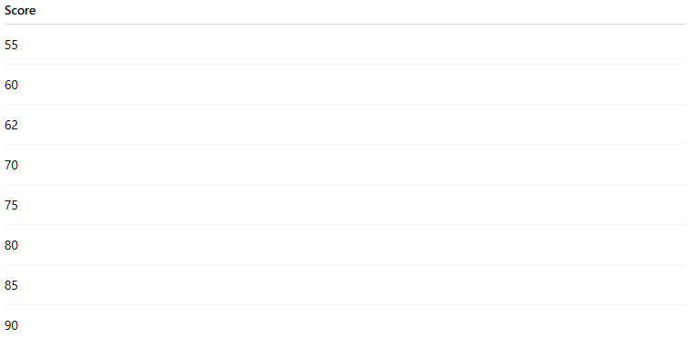
Score
55
60
62
70
75
80
85
90
Histogram Representation:
- x-axis = Score intervals (e.g., 50–59, 60–69, 70–79, 80–89, 90–99)
- y-axis = Number of students in each interval
- Bars represent how many scores fall into each range
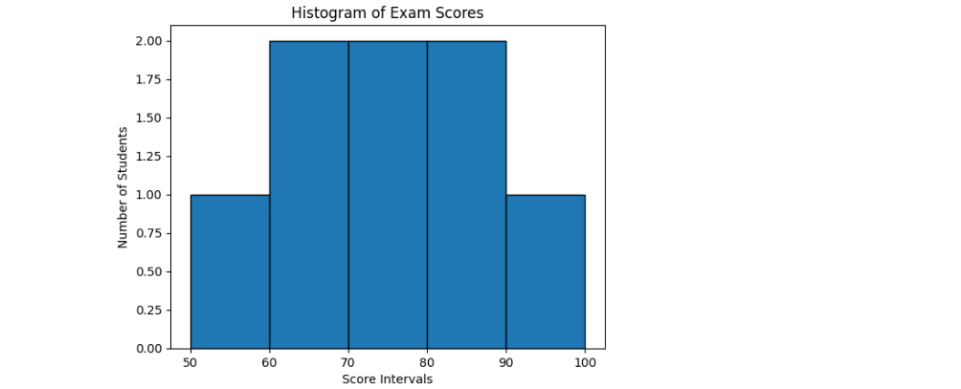

Applications
# Source: AI Source: Provided by: [Data Path: Persons Table -> ID Column: 1, Name_En Column: Motasem Essam] -> From: [Chatgpt (GPT‑5 Mini)] on [12/10/2025]
- Understanding data distribution (normal, skewed, uniform)
- Identifying outliers and gaps in data
- Exploratory Data Analysis (EDA)
- Comparing distributions across datasets

Advantages
# Source: AI Source: Provided by: [Data Path: Persons Table -> ID Column: 1, Name_En Column: Motasem Essam] -> From: [Chatgpt (GPT‑5 Mini)] on [12/10/2025]
- Provides clear visual of frequency distribution
- Easy to interpret shape, spread, and central tendency
- Useful for numerical data analysis

Disadvantages
# Source: AI Source: Provided by: [Data Path: Persons Table -> ID Column: 1, Name_En Column: Motasem Essam] -> From: [Chatgpt (GPT‑5 Mini)] on [12/10/2025]
- Not suitable for categorical data
- Choice of bin size affects interpretation
- Can become misleading if bins are too wide or narrow

Vertical Bar Chart vs Histogram
# Source: AI Source: Provided by: [Data Path: Persons Table -> ID Column: 1, Name_En Column: Motasem Essam] -> From: [Chatgpt (GPT‑5 Mini)] on [12/10/2025]
Vertical Bar Charts and Histograms look similar (both use vertical bars), but they are different in purpose, data type, and interpretation. Here's a detailed comparison:

1. Data Type
# Source: AI Source: Provided by: [Data Path: Persons Table -> ID Column: 1, Name_En Column: Motasem Essam] -> From: [Chatgpt (GPT‑5 Mini)] on [12/10/2025]
- Vertical Bar Chart: Represents categorical data (e.g., product types, survey responses).
- Histogram: Represents continuous numerical data that is grouped into intervals or bins (e.g., exam scores, heights, temperatures).

2. Bar Meaning
# Source: AI Source: Provided by: [Data Path: Persons Table -> ID Column: 1, Name_En Column: Motasem Essam] -> From: [Chatgpt (GPT‑5 Mini)] on [12/10/2025]
- Vertical Bar Chart: Each bar represents a category and its value or count.
- Histogram: Each bar represents a range (bin) of values and the frequency of data points in that range.

3. Bar Width
# Source: AI Source: Provided by: [Data Path: Persons Table -> ID Column: 1, Name_En Column: Motasem Essam] -> From: [Chatgpt (GPT‑5 Mini)] on [12/10/2025]
- Vertical Bar Chart: Bars are usually separated with spaces to emphasize discrete categories.
- Histogram: Bars touch each other because bins are continuous, showing that the data intervals are connected.

4. Purpose
# Source: AI Source: Provided by: [Data Path: Persons Table -> ID Column: 1, Name_En Column: Motasem Essam] -> From: [Chatgpt (GPT‑5 Mini)] on [12/10/2025]
- Vertical Bar Chart: Compare values across categories.
- Histogram: Analyze the distribution, shape, and spread of a continuous dataset.

5. Example
# Source: AI Source: Provided by: [Data Path: Persons Table -> ID Column: 1, Name_En Column: Motasem Essam] -> From: [Chatgpt (GPT‑5 Mini)] on [12/10/2025]
Vertical Bar Chart (Categorical):
Products sold: Laptop = 500, Phone = 700, Tablet = 300
Histogram (Continuous):
Exam scores (50–59: 2 students, 60–69: 3 students, 70–79: 5 students…)
- In the bar chart, each bar is a product category.
- In the histogram, each bar is a score interval (bin).

✅ Summary
# Source: AI Source: Provided by: [Data Path: Persons Table -> ID Column: 1, Name_En Column: Motasem Essam] -> From: [Chatgpt (GPT‑5 Mini)] on [12/10/2025]
- Bar Chart = Categorical comparison
- Histogram = Numerical distribution
Even though both use vertical bars, the type of data and interpretation are completely different.

